The Toolbox folder contains python ui.py file, when the voice cloning program is initiated, the UI opens this:

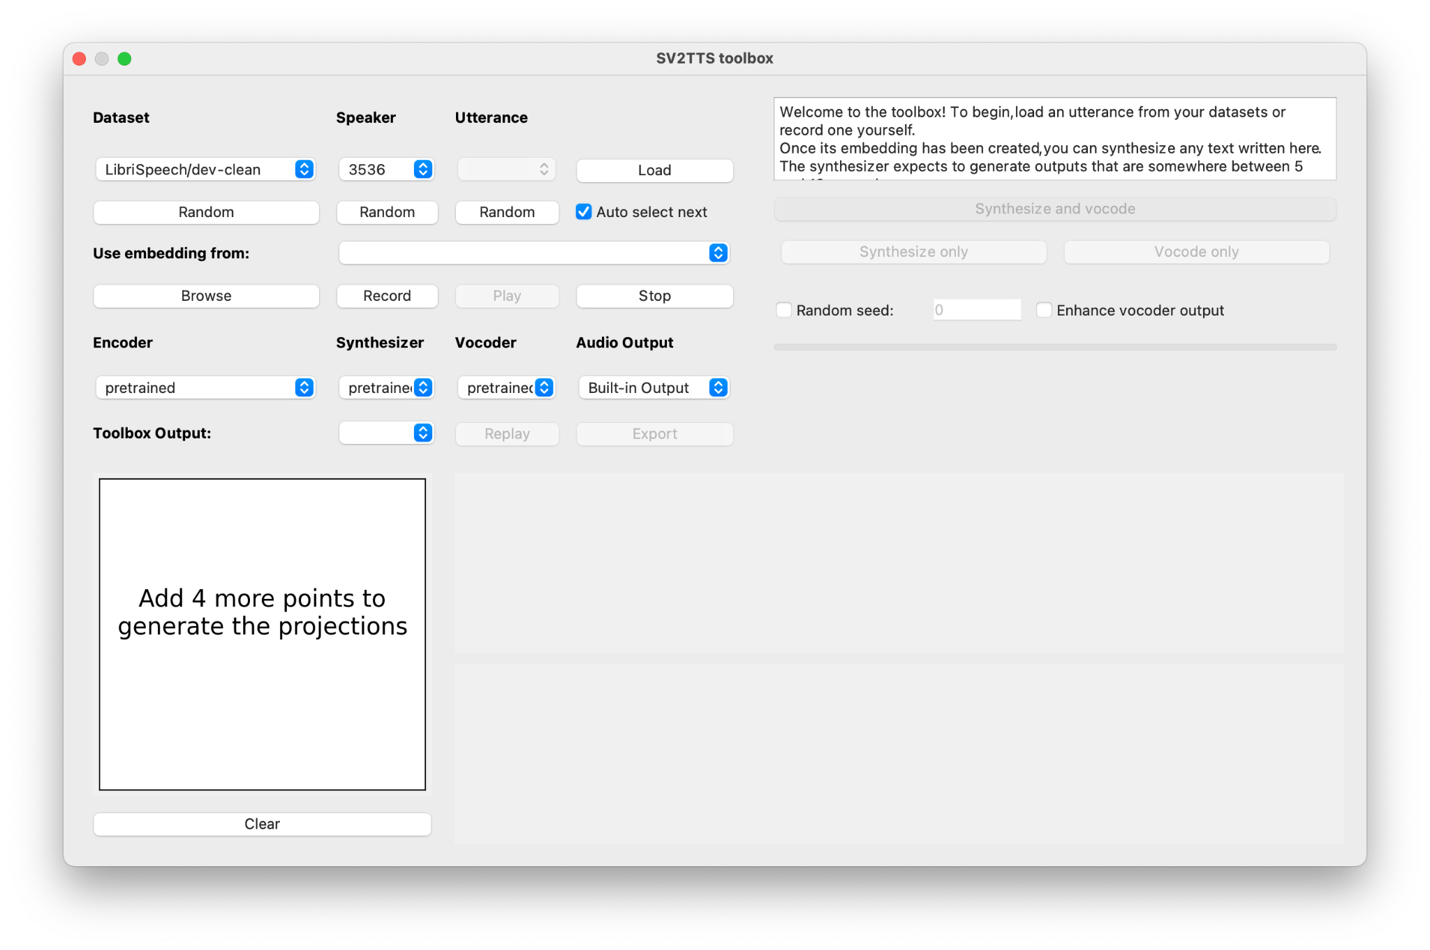

Inside the ui.py file, there is a code, default_text, which is what I am trying to modify.

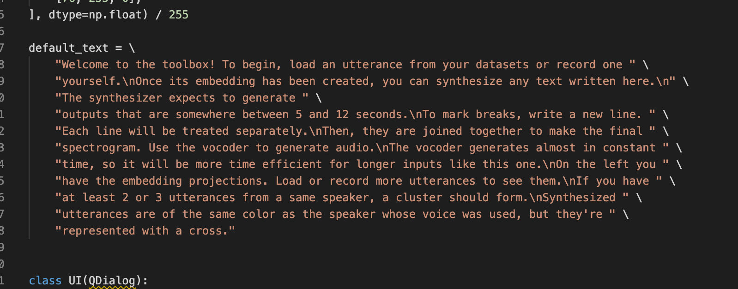

That is what shows in the UI plain edit text box.

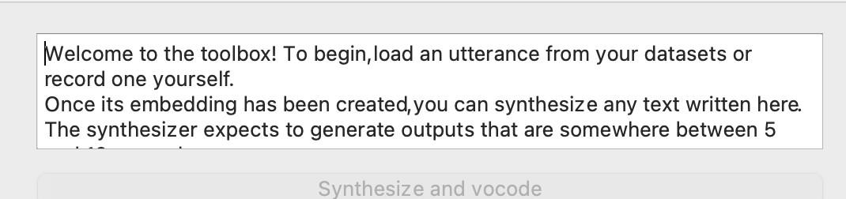

I created a separate python file called Speech.py, that basically transcribes speech recognized from the Microphone to text.   
For testing purposes, to stop the speech recognition for any reason, saying the word “exit”, stops the speech recognition.

So, what I wanted to do is import the speech.py file into the ui.py file, and modify the “default_text” code so the text recognized from the speech goes to the plain edit text box in the UI as shown instead of the pre-written text that was in the code.

But when I did the changes, I got Traceback and exceptions, shown below:

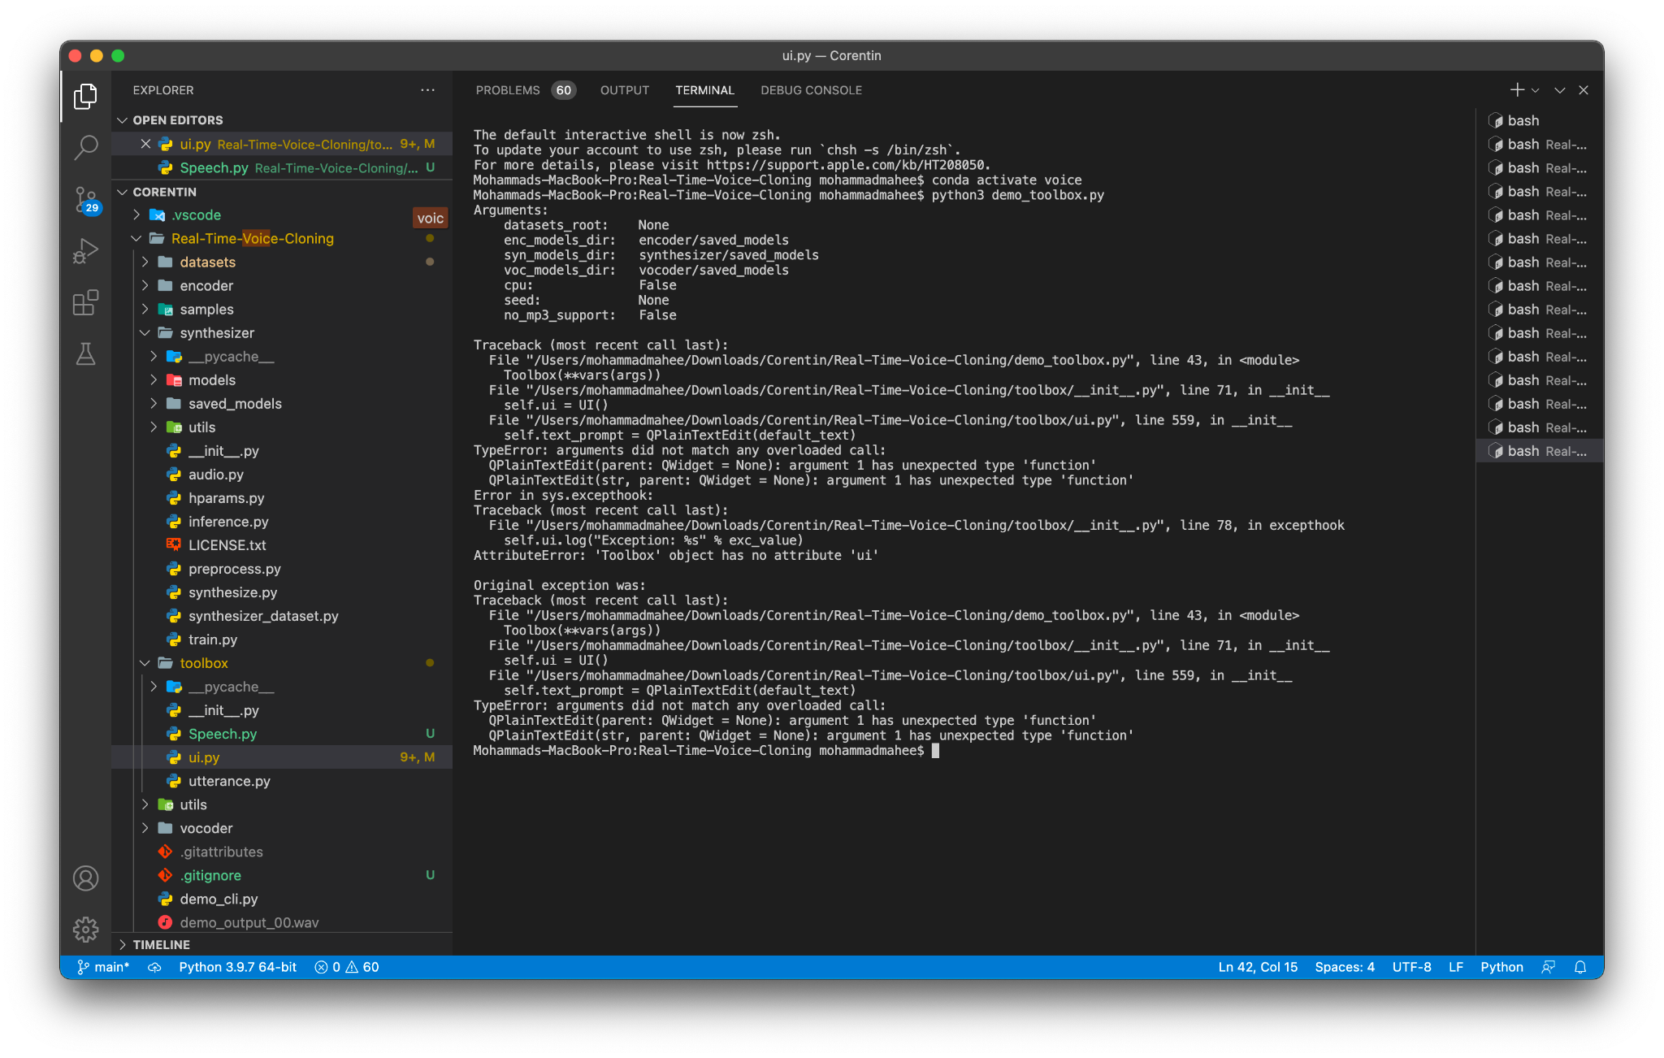

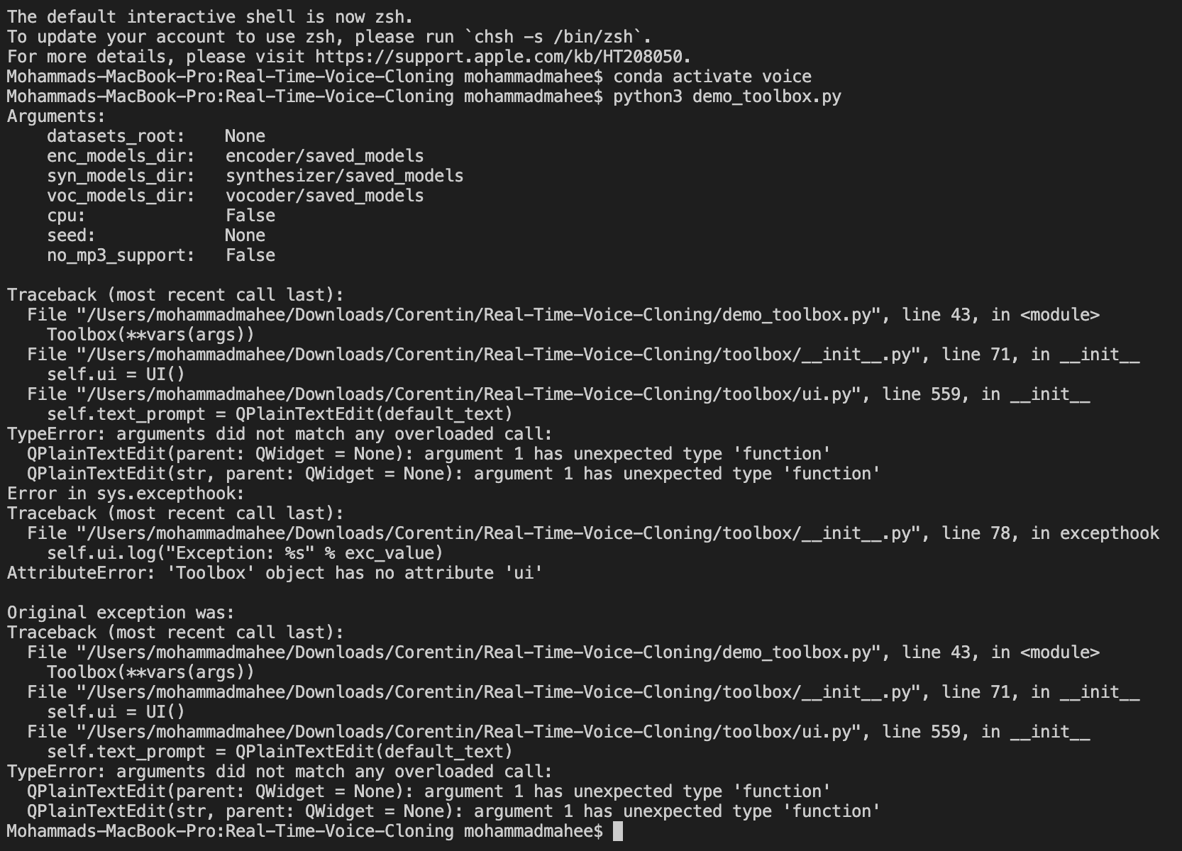

And, I have tried multiple attempts to find the solution, but wasn’t sure exactly how to fix the code in order to make the speech to text work in the UI.

Folders description on Git:

The “Original” folder in the Github contains the toolbox files that isn’t modified

And the “modified” folder contains the python file that I have tried modifying.

References:

Github Repo for the Voice Cloning, that includes all the files to launch the program: <https://github.com/CorentinJ/Real-Time-Voice-Cloning>